**Chapter 5: Switching Methods**

1. **Introduction**

When there are many devices, it is necessary to develop suitable mechanism for communication between any two devices. One alternative is to establish point-to-point communication between each pair of devices using mesh topology. However, mesh topology is impractical for large number of devices, because the number of links increases exponentially (n(n-1)/2, where n is the number of devices) with the number of devices. A better alternative is to use switching techniques leading to switched communication network. In the switched network methodology, the network consists of a set of interconnected nodes, among which information is transmitted from source to destination via different routes, which is controlled by the switching mechanism.

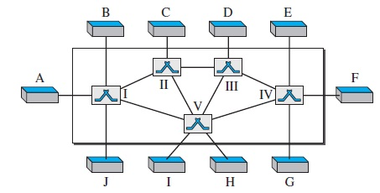

Figure 1. Switched network

Switching can be divided in three categories:-

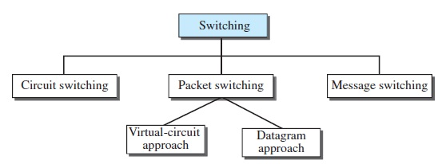

Figure 2. Switching categories

1. **Circuit Switched Networks**

A circuit-switched network consists of a set of switches connected by physical links. A connection between two stations is a dedicated path made of one or more links. However, each connection uses only one dedicated channel on each link.

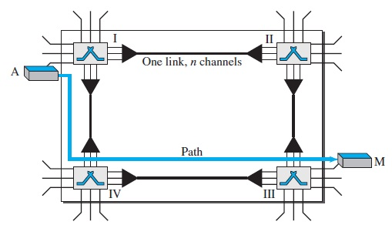

Figure 3. A circuit switched network

When end system A needs to communicate with end system M, system A needs to request a connection to M that must be accepted by all switches as well as by M itself. This is called the setup phase; a channel is reserved on each link, and the combination of circuits or channels defines the dedicated path. After the dedicated path made of connected circuits (channels) is established, the data-transfer phase can take place. After all data have been transferred, the circuits are torn down.

**Setup phase**

In the setup phase, the stations must make a reservation for the resources to be used during the communication. These resources, such as channels, switch buffers, switch processing time, and switch input/output ports, must remain dedicated during the entire duration of data transfer until the teardown phase.

Before the two parties can communicate, a dedicated circuit needs to be established. The end systems are normally connected through dedicated lines to the switches, so connection setup means creating dedicated channels between the switches. For example, in Figure 3, when system A needs to connect to system M, it sends a setup request that includes the address of system M, to switch I. Switch I finds a channel between itself and switch IV that can be dedicated for this purpose. Switch I then sends the request to switch IV, which finds a dedicated channel between itself and switch III. Switch III informs system M of system A's intention at this time. In the next step to making a connection, an acknowledgment from system M needs to be sent in the opposite direction to system A. Only after system A receives this acknowledgment is the connection established.

**Data transfer phase**

After the connection has been established, the two devices can transfer data.

**Teardown phase**

When one of the parties needs to disconnect, a signal is sent to each switch to release the resources.

1. **Packet switching**

In data communications, we need to send messages from one end system to another. If the message is going to pass through a packet-switched network, it needs to be divided into packets of fixed or variable size. The size of the packet is determined by the network and the governing protocol. In packet switching, there is no resource allocation for a packet. This means that there is no reserved bandwidth on the links, and there is no scheduled processing time for each packet. Resources are allocated on demand. The allocation is done on a first come, first-served basis. When a switch receives a packet, no matter what is the source or destination, the packet must wait if there are other packets being processed.

* 1. **Datagram networks**

In a datagram network, each packet is treated independently of all others. Even if a packet is part of a multipacket transmission, the network treats it as though it existed alone. Packets in this approach are referred to as datagrams. Datagram switching is normally done at the network layer.

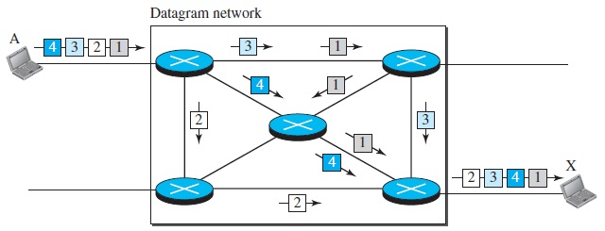

Figure 4. A datagram network

In this example, all four packets (or datagrams) belong to the same message, but may travel different paths to reach their destination. This is so because the links may be involved in carrying packets from other sources and do not have the necessary bandwidth available to carry all the packets from A to X. This approach can cause the datagrams of a transmission to arrive at their destination out of order with different delays between the packets. Packets may also be lost or dropped because of a lack of resources.

* 1. **Virtual-Circuit Networks**

A virtual-circuit network is a cross between a circuit-switched network and a datagram network. It has some characteristics of both.

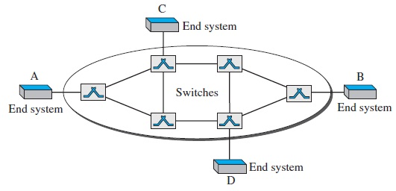

Figure 5. Virtual Circuit Network

As in a circuit-switched network, a source and destination need to go through three phases in a virtual-circuit network: setup, data transfer, and teardown. In the setup phase, the source and destination use their global addresses to help switches make table entries for the connection. In the teardown phase, the source and destination inform the switches to delete the corresponding entry. Data transfer occurs between these two phases. We first discuss the data transfer phase, which is more straightforward; we then talk about the setup and teardown phases.

**Setup phase**

In the setup phase, a switch creates an entry for a virtual circuit. For example, suppose source A needs to create a virtual circuit to B. Two steps are required: the setup request and the acknowledgment.

Setup request

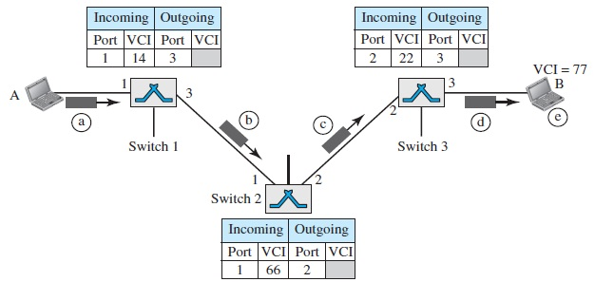

Figure 6. Setup request in a Virtual Circuit Network

Acknowledgement

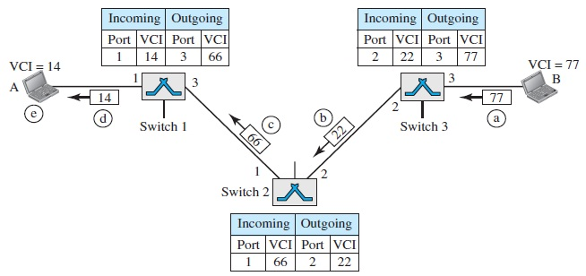

Figure 7. Setup acknowledgement in a Virtual Circuit Network

**Data transfer phase**

To transfer a frame from a source to its destination, all switches need to have a table entry for this virtual circuit. The table, in its simplest form, has four columns. This means that the switch holds four pieces of information for each virtual circuit that is already set up.

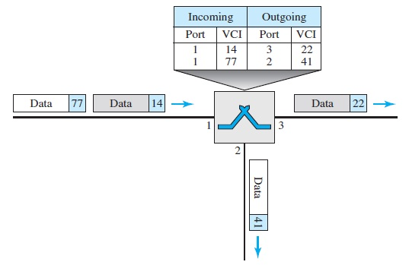

Figure 8. Tables in a Virtual Circuit Network

**Teardown phase**

In this phase, source A, after sending all frames to B, sends a special frame called a teardown request. Destination B responds with a teardown confirmation frame. All switches delete the corresponding entry from their tables.